Booking Procedure for St Patrick’s College Chapel

The following information explains the steps you will need to take if you would like to make a reservation for St Patrick’s College Chapel.
Families are asked to make a payment of $500 to assist with the upkeep of this beautiful building.
Confirmed Old Collegians Association Life Members are eligible to receive a $200 discount and thus are only required to make a payment of $300.
The option to donate this amount to the College Building Fund is available. It should be noted that donations to the College Building Fund are tax deductible.
Note that this form is designed for once-off bookings of the Chapel for events such as weddings, funerals etc. Community groups and/or organisations wishing to enter into arrangements for ongoing hire/use of the College Chapel are encouraged to contact the Chapel Sacristan Helen Lee via email at hlee@stpats.vic.edu.au.

1. BOOKING
All enquiries should be directed to the Chapel Sacristan Helen Lee via email at hlee@stpats.vic.edu.au

2. PRIEST /MINISTER
You will need to contact the Priest/Minister directly to make arrangements for your wedding.

3. CONFIRMATION OF BOOKING
To confirm your booking date and time forward a deposit of $100 with the attached personal information sheet to the College Shop, within one month of initial contact with the Chapel Co-Ordinator.

4. REHEARSALS
Bookings for rehearsals must be made well in advance to ensure the building can be opened by the Chapel Co-Ordinator.

5. COLLEGE AREAS
A request must be made on the booking form if other rooms or areas of the College are required.
Eg: reception, OCA Pavilion or grounds for photographs.

6. WEDDING/MASS BOOKLETS
These are to be organised by the family. May we suggest that the map of the College grounds and parking areas be included with your invitations?

7. MUSIC REQUIREMENTS
Please confirm with the Chapel Co-Ordinator if you would like to use the Chapel organ and would like to contact details for an organist. Couples are welcome to use other musicians. A sound system is available.

8. FLOWERS
The College normally attends to flower arrangements in the Chapel. However, families may prefer to look after flower arrangements themselves and to take these on to the reception after the wedding ceremony. This is perfectly acceptable but would normally be discussed with the College’s Chapel Co-Ordinator in advance.
If families would like the Chapel Co-Ordinator to supply and arrange special flowers, for the occasion (within a fixed budget), the cost would be passed on to the family. Usually the flowers would then remain in the Chapel after the ceremony. If families want the Chapel Co-Ordinator to organise the flowers and then remove, all costs would be worn by the family. This once again would be negotiated with the Chapel Co-Ordinator. Please note that Chapel vases must remain on the property.

9. CONFETTI
Confetti is not to be used in the College buildings or grounds.
Family and friends should be advised of the requirement. Dried flowers are acceptable.

10. GENERAL INFORMATION
Children must be supervised at all times. St Patrick’s College and its surrounds are a smoke free zone.

Our very best wishes for a happy and memorable day.
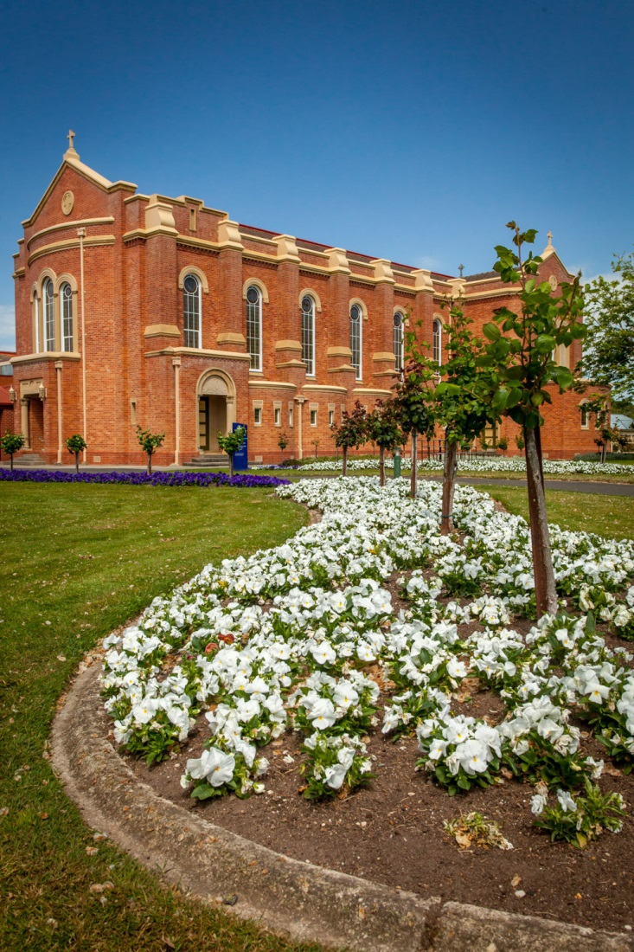
St Patrick’s College Chapel Booking Form

To confirm your booking, please return this form with your deposit to the College Shop, St Patrick’s College, 1431 Sturt Street, Ballarat 3350. Further details can be advised closer to the day.

Date of Booking Time of Booking

Name of Priest/Minister

Rehearsal
Access to the Chapel is required on the following: Date Time

Music
Name of your Musician/Musical Group:

Flowers
Access to the Chapel is required on: Date Time

Photographs
Do you require use of the College for photographs? YES NO

The College grounds? YES NO

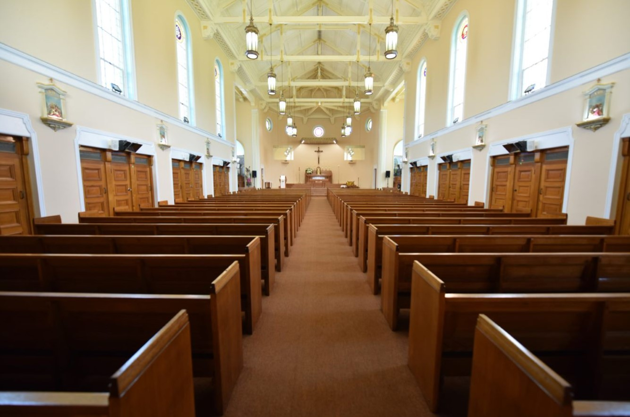

Payment
We enclose $100 cash/cheque payable to St Patrick’s College Building Fund as deposit

We agree to pay a minimum balance of $400 one week prior to our booking date or $200 for confirmed Old Collegian’s Life Membership. (To make a credit card payment contact the College Shop on 5322 4313)

Wedding Party
(If you or any members of your bridal party are Old Collegians please include your alumni year)

Groom’s Name ___________________________ Bride’s Name _____________________________

Address ____________________________ Address _____________________________

Phone No. ____________________________ Phone No. ______________________________

Alumni Year _____________

Attendant’s Name __________________________ Attendant’s Name ________________________

Address ___________________________ Address ________________________

Phone No ___________________________ Phone No _________________________

Attendant’s Name __________________________ Attendant’s Name _________________________

Address ____________________________ Address ________________________

Phone No ____________________________ Phone No _________________________

We agree to the terms and conditions as outlined in the booking procedure. Signed

Groom’s Signature ______________________________ Bride’s Signature____________________________

Date ______________________________ Date ____________________________

